Research Activities Fund Report (SGS14R)

Notes:
- This Research Activities Fund Report should be completed and submitted to the Chow Yei Ching School of Graduate Studies within two months after completing your research activities.
- Reimbursement of the Research Activities Fund will be made directly to the student’s bank account as listed in the Scholarship and Financial Aid function under AIMS. For students who have not provided their bank account information before or would like to change their bank account for receiving Scholarship/Financial Aid payments, please fill in a “Scholarship and Financial Aid - Bank Account Information Form” (obtainable at SGS) and attach the completed form to this Research Activities Fund Report.

Section A (To be completed by the awardee) (* please delete as appropriate)
1. | Personal Particulars
 | Name: |  |  |  |  | Student No.:
 | School/Department: |  |  |  | Programme: |  |  |  | Mode of Study:
 | Contact Phone No.: |  |  | Source of Funding:
Are you a Hong Kong PhD Fellowship (HKPF) recipient? No Yes
(If yes, please state the expenses incurred from the cost of one return passage below to claim for reimbursement through the “Conference and Research Related Travel Allowance of Hong Kong PhD Fellowship Scheme”: Currency: ; Amount: )
 | Are you a Presidential PhD Scholarship (PPS) recipient? No Yes
Have you applied for the Financial Support to PhD Students working in overseas high ranking university or Top 3 Universities in a Country or National Laboratories?
No (this is my first application) Yes (Only opt for once and the choice made is irreversible)

- Claim for Reimbursement of Research Activities Fund

Actual leave period: | From: to: ( months and days)
Location(s) (names of cities and countries) where the research activities were undertaken:

Funds claimed: HK$
Regular Student and HKPFS Recipients: i.e. duration in months x HK$5,000 per month, up to a maximum amount of HK$30,000. If the leave period is not on a full month basis, funding will be provided on a pro-rata basis.

Research Activity Fund for PPS Recipients: HK$8,000 per month, maximum 12 months. If the leave period is not on a full month basis, funding will be calculated on a pro-rata basis

Research Activity Fund for Working in in overseas high ranking university or Top 3 Universities in a Country or National Laboratories: HK$5,000 per month, maximum 12 months. If the leave period is not on a full month basis, funding will be calculated on a pro-rata basis. Transportation allowance of HK$15,000 at maximum with direct round trip economy flight/ground transportation (e.g. train, coach) on a reimbursement basis.

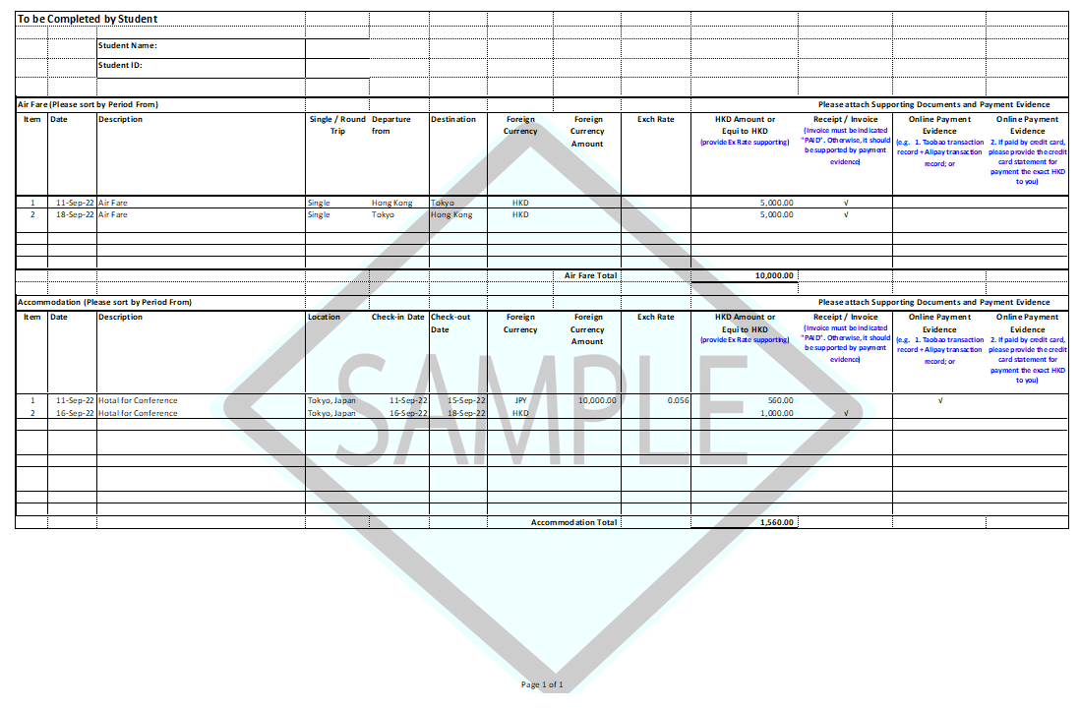
To be Completed by Student
 |  | Student Name:
 |  | Student ID:
Air Fare (Please sort by Period From) |  |  |  |  |  |  | Please attach Supporting Documents and Payment Evidence
Item | Date | Description | Single / Round Trip | Departure from | Destination | Foreign Currency |  | Foreign Currency Amount | Exch Rate | HKD Amount or  Equi to HKD  (provide Ex Rate supporting) | Receipt / Invoice  (Invoice must be indicated "PAID". Otherwise, it should be supported by payment evidence) | Online Payment Evidence  (e.g. 1. Taobao transaction record + Alipay transaction record; or | Online Payment Evidence  2. If paid by credit card, please provide the credit card statement for payment the exact HKD to you)
1
2
 |  |  |  |  |  |  |  | Air Fare Total

Accommodation (Please sort by Period From) |  |  |  |  |  |  | Please attach Supporting Documents and Payment Evidence
Item | Date | Description | Location | Check-in Date | Check-out Date | Foreign Currency |  | Foreign Currency Amount | Exch Rate | HKD Amount or  Equi to HKD  (provide Ex Rate supporting) | Receipt / Invoice  (Invoice must be indicated "PAID". Otherwise, it should be supported by payment evidence) | Online Payment Evidence  (e.g. 1. Taobao transaction record + Alipay transaction record; or | Online Payment Evidence  2. If paid by credit card, please provide the credit card statement for payment the exact HKD to you)
1
2
 |  |  |  |  |  |  |  | Accommodation Total |  | -

3. Report on Research Activities
Please provide (a) a brief summary of your research activities and outcomes; and (b) a brief assessment of the value and usefulness of the activities to your research (not less than 200 words) (use separate sheets if necessary):

4. | List of Supporting Document(s) Required
Please attach the following document(s) to facilitate our processing. Applications with incomplete supporting document(s) will not be processed. Document(s) submitted are not returnable:

- A copy of approval letter on research activities fund
- Original receipts/documentary proof (e.g. boarding pass, air ticket, hotel receipt, etc.) for attending the approved research related activity indicating your actual leave period.
- (For HKPF recipient only) Original receipts for:
- the cost of one return passage by the most economical means available.

 | Signature: |  | Date:

Section B Recommendation of the Supervisor (*please delete as appropriate)

I acceptance of the student’s report on the research-related activities.
Other comments, if any:
Name of Supervisor |  | Signature |  | Date

Section C Endorsement by the School Dean/Department Head (*please delete as appropriate)

I endorse/do not endorse* the supervisor’s recommendation stated above.

Other comments, if any:

Signature of School Dean/Department Head Date

For internal use only
To: FO

The student has fulfilled the requirements for claiming the Research Activities Fund. Please check the receipts attached and arrange for reimbursement through:
Checked by
 | CO | EO
Name
Ext.
Date

Provider | SFAID(s) | Appr. Amt (HK$)
□ SGS | □ 669 (UGC) □ 766 (non-UGC)
□ Col/Sch/Dept | □ 858 (non-UGC)
□ Supervisor | □ 856 (UGC-related) □ 857 (External)
□ HKPFS | □ #610 (Travel Allowance)
□ PPS | □ 1436 (Research Activity Fund: HK$8,000 per month, maximum 12 months)
□ Financial Support to PhD Students Working in VHRUs or Top 3 Universities in a Country or National Laboratories | □ 1543 (Research Activity Fund: HK$5,000 per month,  maximum 12 months) (UGC).  □ 1544 (Research Activity Fund: HK$5,000 per month,  maximum 12 months) (non-UGC)  □ 1545 (Transportation allowance of HK$15,000 at maximum with direct round trip economy flight/ground transportation (e.g. train, coach) on a reimbursement basis) (UGC)  □ 1546 (Transportation allowance of HK$15,000 at maximum with direct round trip economy flight/ground transportation (e.g. train, coach) on a reimbursement basis) (non-UGC)
# For reimbursement of the cost of one return passage

N:\SGS Forms\SGS14R_Research Activities Fund Report.doc
Aug 2023

